Name:______________________ Class:________
WEEK 9
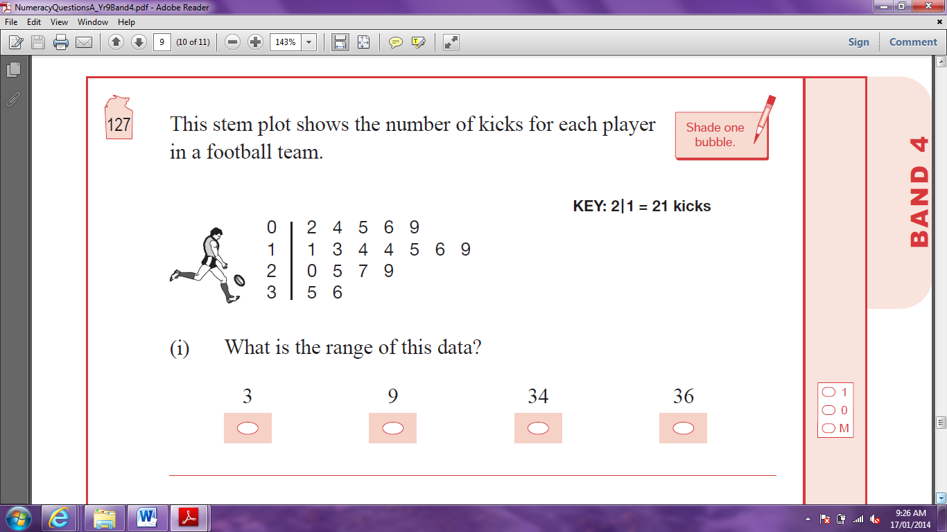
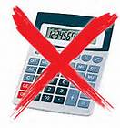
- This stem-and-leaf plot shows the number of kicks for each player in a football team. What is the range for this data?
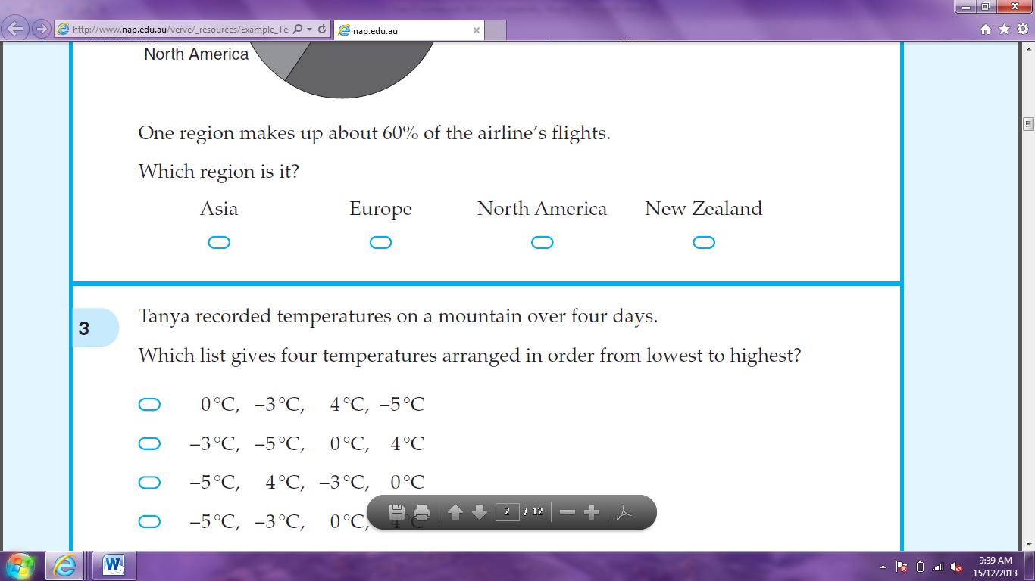



3 9 34 36

- Which temperature is between -2°C and -3°C?




-0.28°C -1.78°C -2.91°C -3.01°C
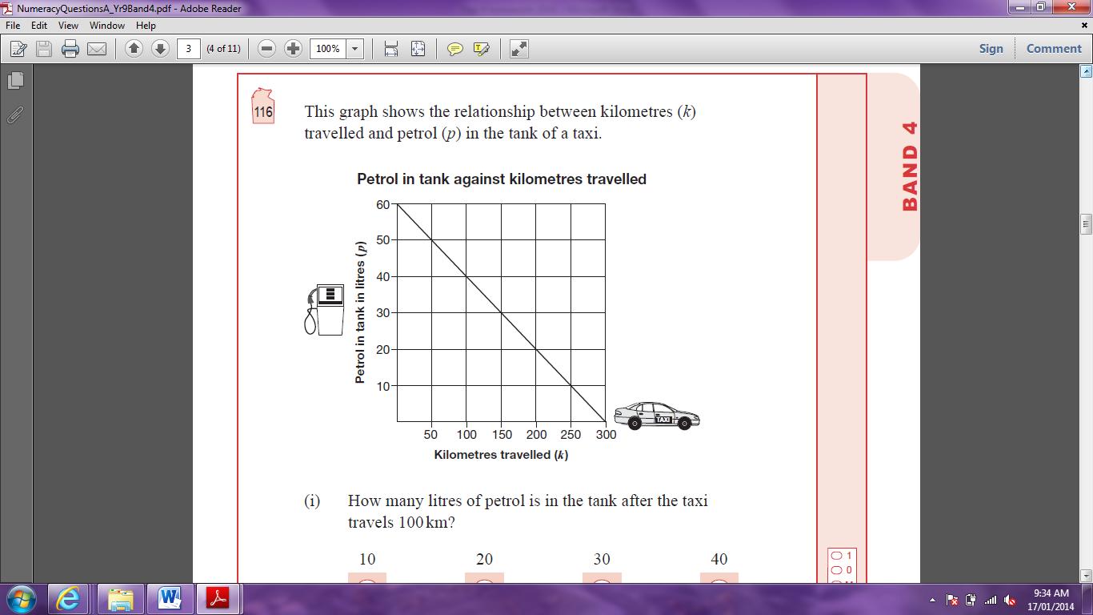
- This graph shows the relationship between kilometres (k) travelled and petrol (p) in the tank of a taxi. How many litres of petrol is in the tank after the taxi travels 100km?

- Kiri has to find the value of 20 – 12 × without using a calculator. Which calculation should she do first?




20 – 12 12 ÷ 9.5

- Janice has three coins in her pocket and they are all different from each other. Jeremy has three coins in his pocket and they are all the same as each other. Jeremy has twice as much money as Janice. What are the coins they each have?

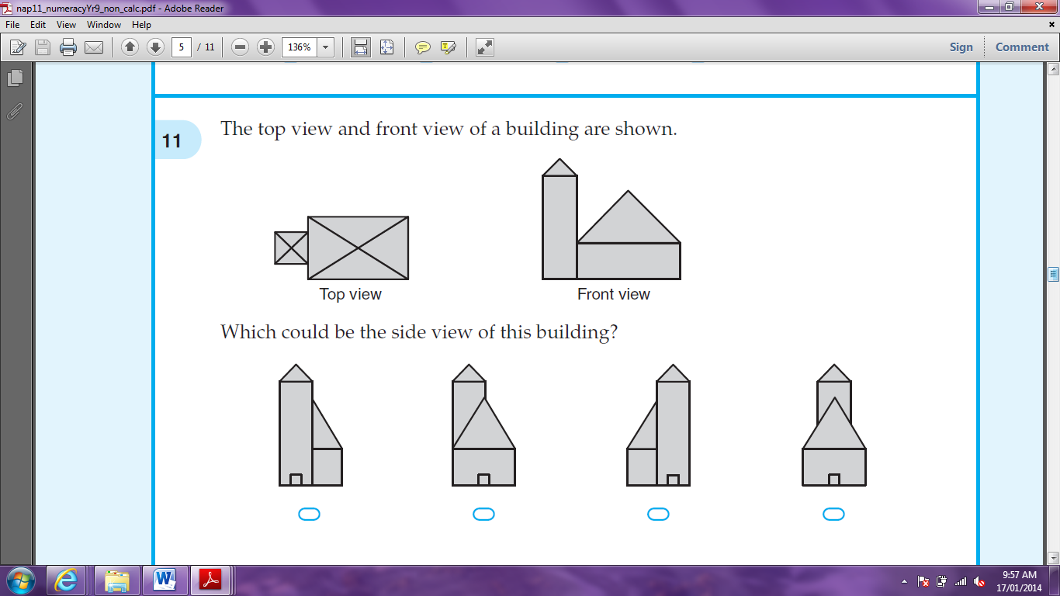
- The top view and front view of a building are shown.


Which could be the side view of this building?

- 5b – 4 = 2b + 17. What is the value of b in this equation?

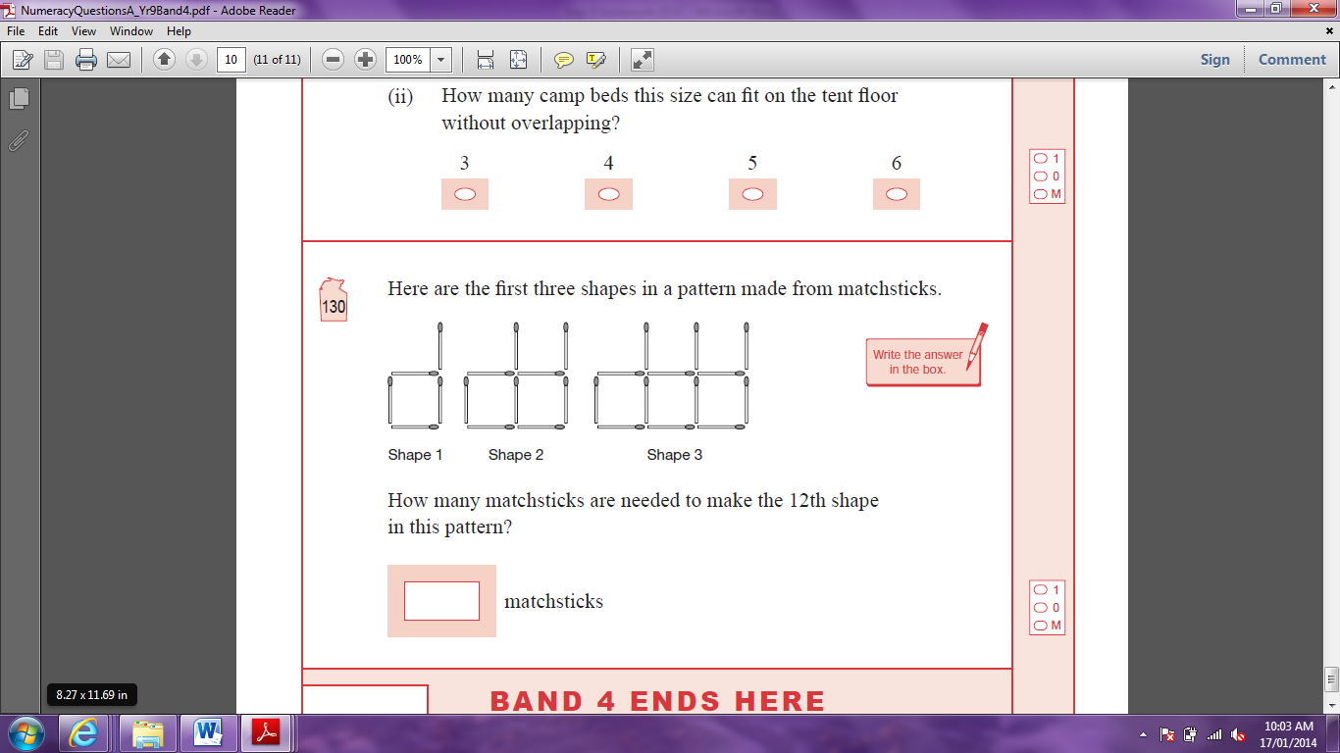
- Here are the first three shapes in a pattern made from matchsticks. How many matchsticks are needed to make the 12th shape in this pattern?

- A ticket costs $75. A fee of 10% is added to the price. Which calculation will give the new price?




75 + 10 75 + 0.1 75 x 0.1 75 x 1.1

- What is the value of x°?

- The area of this rectangle is 28mm². Find the length of the missing dimension ‘x’.

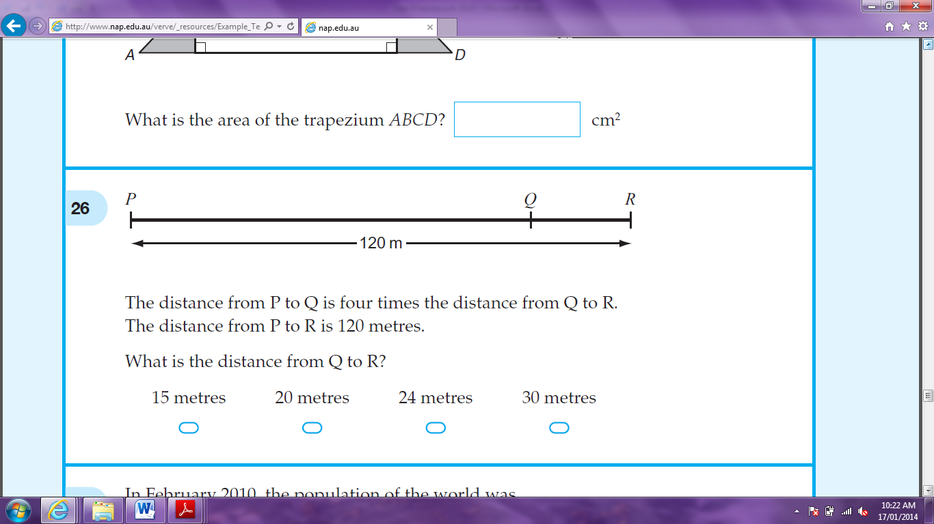
- The distance from P to Q is four times the distance from Q to R. The distance from P to R is 120 metres. What is the distance from Q to R?

- The rule to change temperatures in degress Celsius (°C), to temperatures in degress Fahrenheit (°F) is . The maximum temperature today was 35°C. What is this in degrees Fahrenheit?

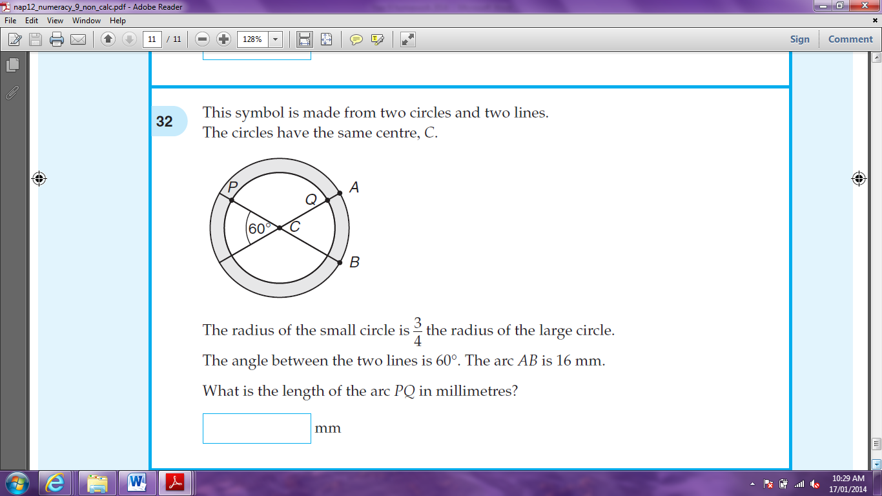
- This symbol is made from two circles and two lines. The circles have the same centre, C. The radius of the small circle is the radius of the large circle. The angle between the two lines is 60°. The arc AB is 16 mm. What is the length of the arc PQ in millimetres?

